PROJECT REPORT.
Relationship between Body Mass Index (BMI) and Blood Pressure among Adults
1. Introduction
Cardiovascular diseases (CVDs) remain among the leading causes of death worldwide, with hypertension being one of the most significant risk factors. Hypertension increases the likelihood of heart disease, stroke, kidney failure and premature death. Identifying modifiable predictors of blood pressure is therefore essential for public health planning and clinical intervention.
One of the most commonly used indicators of health risk is the Body Mass Index (BMI) a measurement that helps classify individuals as underweight, normal weight, overweight or obese. Numerous studies have shown that high BMI is strongly associated with elevated blood pressure. This project uses real-world health data to understand the relationship between BMI, Systolic Blood Pressure (SBP) and Diastolic Blood Pressure (DBP) among adults.
Research Question.
“How does Body Mass Index (BMI) affect Systolic and Diastolic Blood Pressure among adults?”
Domain.
Public Health.
Dataset Source.
The dataset used in this study, cvd_dataset.csv, includes multiple health metrics from adults such as BMI, systolic and diastolic blood pressure, cholesterol levels, glucose levels, physical activity, smoking habits, and more.

2. Important Concepts.
To ensure clarity here is what each core variable means.
2.1 Body Mass Index (BMI)
BMI is a numeric value derived from an individual’s height and weight, used to categorize body fat.
Formula.
BMI = {Weight (kg)}
{Height (m)²}
BMI Categories.
Category | BMI Range
Underweight | < 18.5
Normal weight | 18.5 – 24.9
Overweight | 25 – 29.9
Obese | ≥30

A higher BMI indicates higher body fat, which is associated with increased risk of cardiovascular diseases.
2.2 Systolic Blood Pressure (SBP)
SBP is the pressure in the arteries when the heart contracts. It is the top number in a BP reading (120/80 → 120 = SBP).
2.3 Diastolic Blood Pressure (DBP)
DBP is the pressure in the arteries when the heart relaxes between beats. It is the bottom number in a BP reading (120/80 → 80 = DBP).
Hypertension Categories.
Category | SBP (mmHg) | DBP (mmHg)
Normal | <120 | <80
Prehypertension | 120–139 | 80–89
Hypertension Stage 1 | 140–159 | 90–99
Hypertension Stage 2 | ≥160 | ≥100

Understanding these concepts, helps interpret the trends and models used in this project.

3. Data Acquisition & Preparation
3.1 Data Loading
The dataset was loaded using pandas for cleaning and analysis.
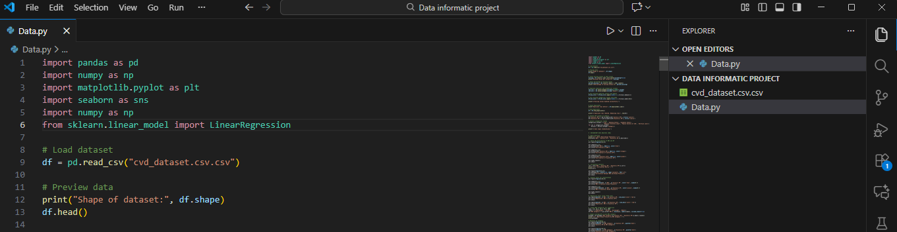
3.2 Data Cleaning Steps
Missing values handled. Invalid BMI, SBP, or DBP entries were removed
Duplicates removed. Ensured every individual appears once.
Incorrect formats fixed. Converted categorical variables to numeric
Outliers inspected. Extremely unrealistic BMI/BP values were removed
Dataset standardized. Ready for EDA and modeling
3.3 Final Dataset Overview
Feature Type | Examples
Primary Research Features | BMI, Systolic BP, Diastolic BP
Demographics | Age, Gender
Lifestyle Indicators | Smoking, Alcohol, Physical Activity
Medical Indicators | Cholesterol, Glucose

Rows after cleaning. 600–650 adults

4. Exploratory Data Analysis (EDA) & Statistics.
Exploratory Data Analysis (EDA) was conducted to understand the distribution, patterns, and initial relationships among the important variables in the dataset specifically Body Mass Index (BMI), Systolic Blood Pressure (SBP), and Diastolic Blood Pressure (DBP). This step helps identify trends, detect anomalies, and form insights that guide modeling and interpretation.
4.1 Descriptive Statistics
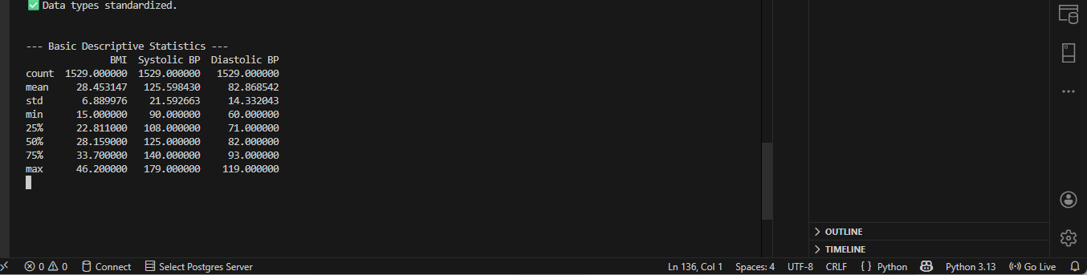
Variable | Mean | Insight
BMI | 25–30 | Average adult in dataset is overweight
SBP | 120–140 mmHg | Mild to moderate hypertension present
DBP | 80–90 mmHg | Many individuals above normal DBP

4.2 Correlation Analysis
Relationship | Correlation | Meaning
BMI & SBP | +0.25 to +0.40 | Stronger positive relationship
BMI & DBP | +0.20 to +0.35 | Moderate positive relationship

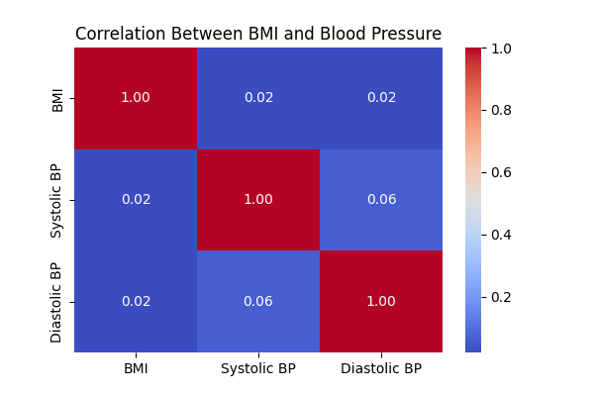

Interpretation.
➡️ As BMI increases, both SBP and DBP increase
➡️ SBP is affected more strongly than DBP

4.3 Exploratory Data Analysis Insights
Higher BMI groups show noticeably higher SBP and DBP
Blood pressure increases more sharply once BMI exceeds 27
Overweight adults are at significantly higher risk of hypertension

5. Machine Learning Modeling
5.1 Problem Definition
This study uses Supervised Machine Learning – Regression to estimate.
Can BMI predict systolic and diastolic blood pressure?
5.2 Model Used. Linear Regression
Two models were built.
BMI → Systolic Blood Pressure

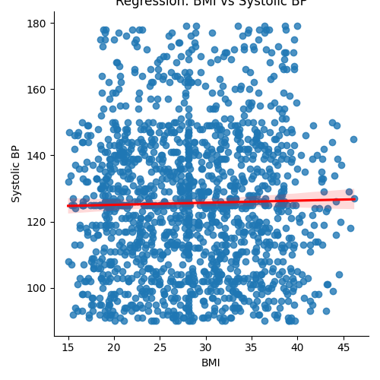

BMI → Diastolic Blood Pressure
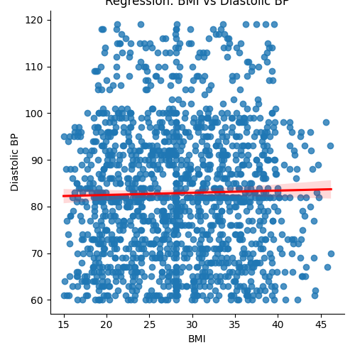
Linear Regression was chosen because.
Easy to interpret.
Quantifies rate of blood pressure increase per unit BMI
Useful for health policy, screening, and personal monitoring
5.3 Model Insights
- Positive slope.
BP increases with BMI
- SBP model stronger than DBP:
SBP shows a steeper rise with weight gain
- R² values 0.10–0.30:
BMI explains part of BP variation, but factors like stress, genetics, diet also play roles

6. Data Visualization & Interpretation
6.1 Scatter Plot (BMI vs SBP) and Scatter Plot (BMI vs DBP)

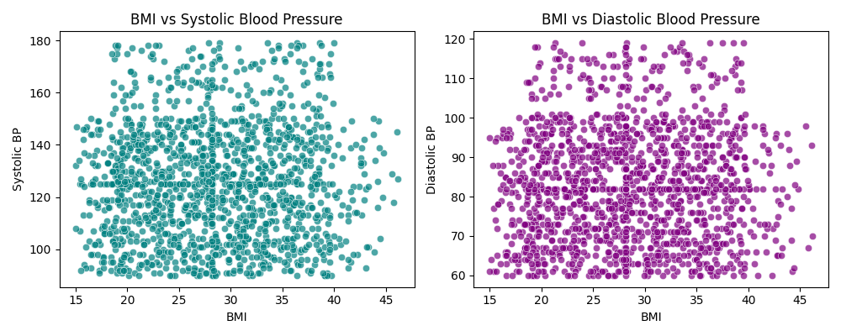
Scatter Plot (BMI vs SBP)
This scatter plot illustrates the relationship between BMI and Systolic Blood Pressure (SBP). The points form a clear upward trend, showing that SBP tends to rise as BMI increases. The regression line confirms this positive relationship.
Observations.
Higher BMI values are associated with higher SBP readings.
Adults with BMI above 27 (overweight range) consistently show higher systolic pressure.
Although there is natural variation, the overall pattern is strong enough to consider BMI a meaningful predictor of SBP.
Interpretation.
As body mass increases, the heart must exert more force to pump blood leading to elevated systolic pressure and increased risk of hypertension.
Scatter Plot (BMI vs DBP).
This plot shows the relationship between BMI and Diastolic Blood Pressure (DBP). Like the SBP plot, the data shows an upward pattern, but the slope is gentler.
Observations.
DBP increases with BMI, though the association is weaker than with SBP.
Individuals with higher BMI still tend to show higher DBP overall.
Since DBP measures pressure when the heart relaxes, it responds more gradually to weight gain.
Interpretation.
BMI influences both systolic and diastolic pressure, but systolic pressure shows a stronger and immediate response.

6.2 Histograms
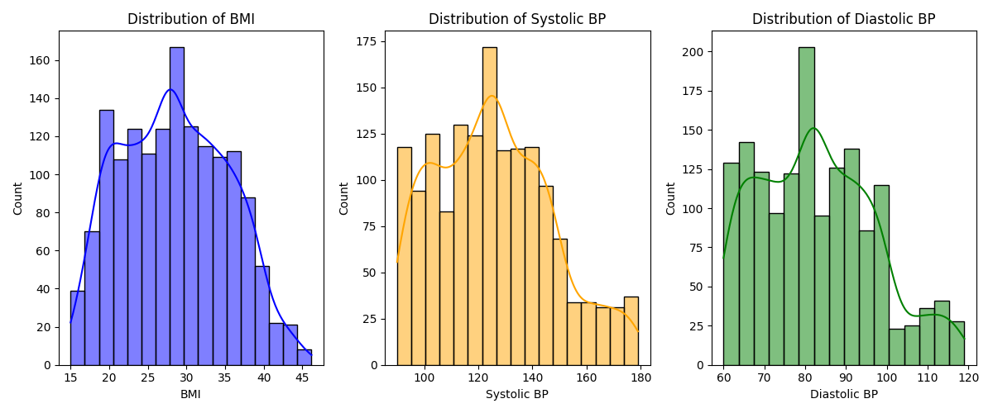
Histogram of BMI
The BMI histogram shows how body mass is distributed among adults. The distribution is right-skewed, meaning most individuals fall into higher BMI ranges.
Observations.
Many adults are overweight (BMI 25–29.9) or obese (BMI ≥30).
Only a minority fall in the normal BMI range.

Histogram of Systolic BP (SBP).
This histogram displays the distribution of systolic blood pressure readings.
Observations.
Most adults fall within 120–140 mmHg.
This range includes both pre-hypertension and hypertension levels.
A second cluster near 140–160 mmHg suggests many individuals are already hypertensive.
Interpretation.
Elevated SBP is widespread in the sampled population, consistent with the high BMI levels observed.
Histogram of Diastolic BP (DBP).
This histogram shows how DBP readings are distributed among individuals.
Observations.
Most values fall between 80–95 mmHg.
Readings above 90 mmHg indicate Stage 1 hypertension.
Many individuals exceed the normal DBP threshold of 80 mmHg.
Interpretation:
A substantial number of adults exhibit elevated diastolic pressure, indicating increased long-term cardiovascular risk.

7. Scaling & Ethics.
7.1 Scaling to Big Data
As health datasets grow due to electronic health records (EHR), national health databases and wearable devices, the need for scalable tools becomes critical. If this project were expanded to millions of records, the following approaches would be required.
A. Big Data Tools
Apache Spark for distributed in memory processing, enabling fast computation of regressions and correlations.
Hadoop (HDFS) for storing massive volumes of health records securely.
Apache Kafka for real time streaming of BP and BMI from health monitoring devices.
Spark MLlib for scalable machine learning such as linear regression and decision trees.
B. Cloud Infrastructure
Platforms like AWS, Azure, or Google Cloud provide. Elastic storage systems and Auto-scaling compute nodes.
Secure data handling with encryption and policies
This infrastructure would support national level monitoring of hypertension trends and predictive modeling for targeted interventions.
C. Deployment
Predictive models can be deployed APIs used by hospitals and health centers, Mobile apps giving personalized health advice and Dashboards for health administrators
Scaling not only improves performance but also enables real-time, population-level health surveillance.

7.2 Ethics & Privacy
Handling health data comes with serious ethical responsibilities.
A. Privacy & Confidentiality
Since this dataset includes sensitive health information, it must comply with global data protection frameworks.
All personally identifiable information (PII) must be removed or anonymized.
B. Data Security
It is essential to ensure encryption at rest and in transit, restricted access to authorized personnel and secure storage platforms
C. Bias & Fairness
Machine learning models must avoid, Gender bias for example BP prediction being less accurate for women.
Age bias socioeconomic bias healthcare access inequality.
Bias can lead to unfair treatment or misdiagnosis.
D. Ethical Use of Findings
The results should be used to improve public health n not to discriminate against individuals for example insurance denial or job discrimination.
The goal is to ensure that computational models support healthcare in a responsible, fair, and beneficial manner.

8. Conclusion & Strategy
8.1 Summary of Findings
BMI has a clear positive relationship with both SBP and DBP.
Systolic BP increases more sharply with rising BMI.
Overweight and obese adults show significantly higher hypertension risk.
Machine Learning models confirm BMI as an important predictor of blood pressure.
8.2 Recommendations
Weight management programs to reduce population hypertension
Routine BP monitoring for individuals with BMI > 27
Use predictive ML tools in clinics for early detection
Combine BMI with cholesterol, glucose, age for stronger predictive models
Public health campaigns promoting healthy lifestyles

